GLMboost with iRace tuning Summary

Table of Contents:
1. High-Level Summary
2. In-Depth Explanation

___________________________________________________________________________
- High Level Summary:

Part 1:
- Utilizing a GLMboost model with classification thresholds, we can correctly predict 86.67% of game outcomes (0.7 threshold)
- Utilizing a standard GLMboost model (with no thresholds) we can correctly predict the outcome of 68% of games.
  - The baseline was 66% (If positive instances were always predicted)

- The model was very good at predicting when the favorite was going to win.

  - Using the classification thresholds, it ONLY predicted instances where the favorite won and scored a 52/60.

This could be used to the advantage of the user if the goal is to parlay multiple bets together.
- Negative scenarios (underdog winning) would yield a higher return if they hit, but returns may even out if MORE bets were parlayed together. Even if you chose the favorite to win each game.
For example, the following 2 parlays MAY yield the same return
1. Betting 1 underdog to win & 1 favorite to win (2 games)
2. Betting 3 favorites to win (3 games)
Overall: Using classification thresholds, the model was good at predicting instances where the favorite won.

Part 2:
LogSpread_Favorite is the most important indicator of the favorite winning.
- All else equal, once this feature exceeds 2, the probability of a “favorite winning” prediction increases to 0.70.
- It has a larger, positive impact on the chances of the favorite winning - meaning as the value increases, the chances of a favorite winning prediction increases.

Favorite Wide Receiver score was also an important feature which had a larger positive impact on the favorite winning.
- A higher fav wr score increased the chances of the favorite winning.
- As fav wr score evened out & exceed 0, the probability of a positive model prediction increased to > 0.6 and reached 0.70 once the value reached 4.

Favorite total points against was another important feature.
- As this value increased, the probability of a positive outcome increased. (PDPs)
- Consequently, lower values decreased the chances of the favorite winning. (Shap)
  - At first glance this seems counter intuitive. We would think that teams who have not given up many points would be more likely to win (lower points against indicates a higher chance of winning). But the shap plots & pdps suggest otherwise, so consider the following.
- This can be interpreted as - better teams require their opponents to score higher because the observed team is also scoring a larger amount.
- More points required to beat team X suggests that team X scores a larger number of points, thus team X is harder to beat.

Favorite margin of defeat provides a valuable insight that was not anticipated.
- A lower value decreased the chances of the favorite winning.
  - This also seems somewhat counter intuitive. We would think that teams with a smaller margin of defeat would be “better” (more likely to win) since they play in close games.
- This can be interpreted as the team participated in closer games & was not getting "blown out"
- This suggests that the team might have trouble closing out games & performing under pressure
- Since they are losing by smaller margins, they are less clutch - which explains why a lower value decreases the chances of a win.

**Variable Importance, PDPs, & SHAP plots are on the following pages.

Variable Importance:
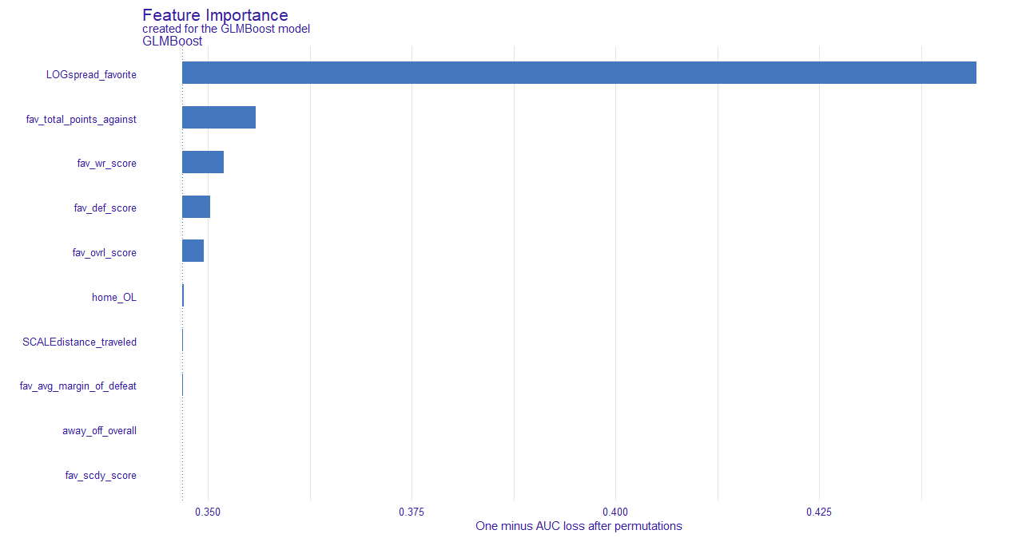

Explanation:
- Variable importance based on 1-AUC after permutations
  - This indirectly gives us the variable importance by assessing the AUC after said feature is permutated
    - For instance, if LOGspread_fav is permutated, 1-AUC = approximately 0.43
      - So as a result, the AUC = 0.57
    - If fav_total_points_agnst is permutated, 1-AUC = approximately 0.36
      - So as a result, the AUC = 0.65
  - Therefore, we can conclude that LOGspread_fav has more importance since the AUC was lower when this variable was permutated
Summary:
- Log Spread was by far the most important variable, this was based off the Las Vegas Spread & transformed to capture absolute versus relative differences
- Fav_total_points_agnst was the second most important variable, but one of the drawbacks of a simple importance plot is that there is no directionality.
  - Intuition tells us that the greater the log spread, the more likely the favorite is to win. And the more points the favorite gives up in a season, the less likely they are to win. But we will not know until we do further investigation (below).

Partial Dependency Plots
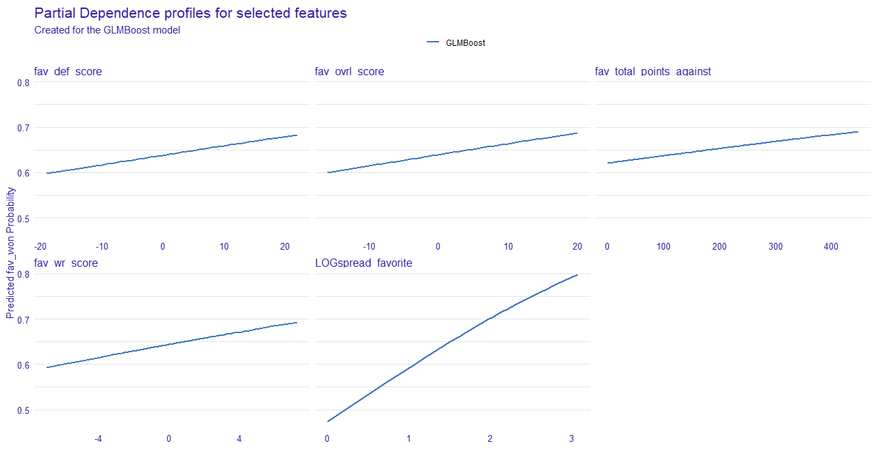
- Above are the partial dependency plots for the 5 most important variables outlined in the previous section.
  - LogSpread_Favorite
    - We can see that as the value increases, the probability of a positive prediction increases as well. This supports the intuition behind the idea of a “spread”
    - We see that once the value reaches 1.5-2, the probability creeps toward 0.70 & anything above a 2 strongly indicates there is a high probability that the favorite will win the game
  - Fav Total Points Agnst
    - This was an interesting feature
    - It is the cumulative sum of the points scored against the favorite team (keeping each season independent)
    - We would think that as the value increased, the probability of the favorite winning would decrease. Since the team is giving up more points.
      - But in each season, it is inevitable that points will be given up. So, the amount will increase throughout the season
        - Because of this, we should refrain from making any assumptions & refer to the SHAP values before a final interpretation is made
  - Fav wr score
    - As the value approaches 0, the favorite winning probability steadily increases. And once the value surpasses 0 & approaches 4, the probability closes in on 0.70
      - We can conclude that when the favorite wr rating is greater than the underdogs scdy rating, the probability of the favorite winning increases.
  - Fav def score & fave ovrl score
    - Both are also supportive of the idea that a higher score will increase the probability of the favorite winning
      - I.E. a team that has better players should have a better chance of winning the game.
Shap Plot:
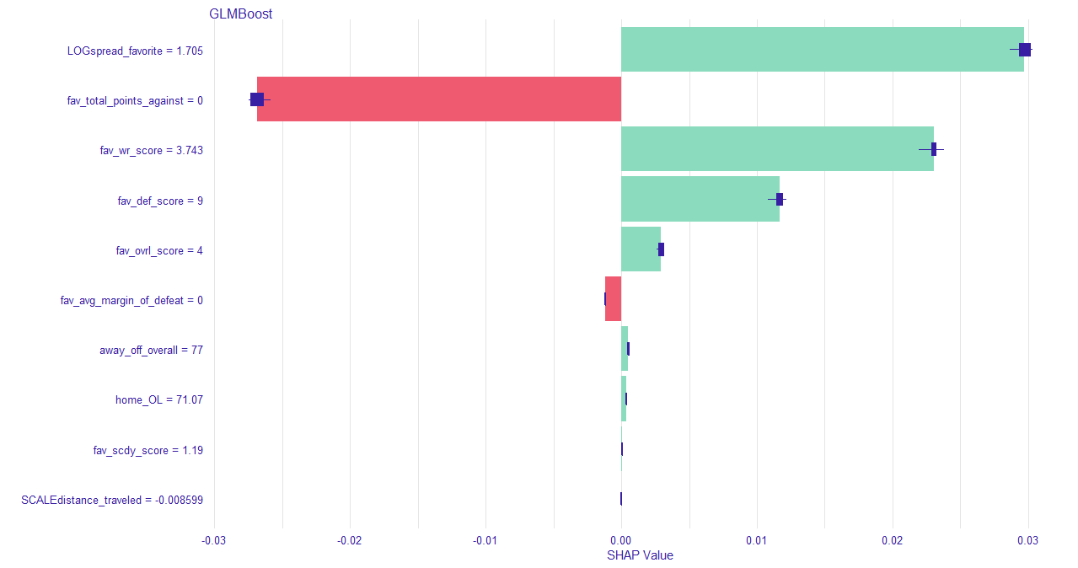

- The SHAP plot allows us to interpret the directionality of variable impact.
- As discussed in the XGBoost summary, the SHAP values are the change in log-odds.
  - Log Spread Favorite
    - A high positive impact on the log-odds.
      - This indicates a high value increases the chances of the favorite winning
  - Fav total points angst
    - A high negative impact on the log odds
      - This means a low value decreases the chances of the favorite winning
        - This aligns with/supports this features PDP
        - This could partially be explained because of the following
          - As the season goes on teams have more and more points scored against them
          - Teams who tally a larger point total against tend to give up points
          - But in our cases, said team is favored.
          - So, this could be explained by teams participating in high scoring games, which tend to have high stakes
          - If a team has a lower value, it either means they are shutting out the opponent, or the other team is not being forced to score a larger number of points to win the game – meaning the favored team is not putting up many points
          - If the value is large, teams are having to score more points to be competitive, meaning that the favored team is also scoring a larger number of points
  - Fav wr score & fav def score
    - A high positive impact on log odds
      - A high value increases the chances of the favorite winning
  - Fav average margin of defeat
    - A lower value decreases the chances of the favorite winning
      - A lower margin of defeat means the team participated in closer games, and they were not being “blown out” by the other team
      - A lower value means they have lost close games
        - This could be interpreted as the favorite has trouble “closing out” or performing under pressure, when they are in a tight game
        - Since a lower value decreases the chances of them winning, this may suggest that the favorite has issues winning close ball games – performing under pressure
          - Which would explain why a lower value decreases the probability of them winning (the favorite is not clutch)

***In depth explanations are on the following pages

- In-Depth Explanation:
Preprocessing:
- Packages are loaded
- Data is loaded, shuffled, & split into training & testing
Variable Selection:
- Used a random forest model on the training data to reduce the feature
  - OOB error for each data point is recorded
    - Prediction error via bagging
    - Bagging: Subsamples with replacement creates the training samples
    - The model is trained on the bagged observations
    - The OOB error is calculated on the observations OOB
    - The selected feature values are permuted for the training data (noise/randomness is added) then the OOB error is computed again
    - The difference between the OOB error before & after the permutation is calculated & this is how importance is determined
      - Mean Decrease Accuracy (MDA)
        - How much the accuracy decreases after the process above
      - Mean Decrease Gini/Impurity (MDG)
        - How much the node purity decreases after the process above
    - Kept variables with an MDA > 0 & an MDG > 5

Preprocessing 2:
- Created the learning tasks for the mlr3 package
- Created the learner for mlr3 (classif.glmboost) with prediction probabilities returned
- Set the parameter search spaces
- Set the evaluation metric (Logloss)
- Set the resampling method to be used (Repeated cross validation (3 repeats on 10 folds))
- Defined a training budget (200 evals (max trials))
- Set the tuning instance
- Set the tuner (irace) – Could be random search, grid search, etc.
- Tuned the model

Explanations:
Learner: GLMBOOST
- A generalized linear model fitted using a boosting algorithm based on component-wise univariate linear models (rdocumentation.org/packages/mboost)
  - Gradient boosting for optimizing arbitrary loss functions where component-wise linear models are used as base learners (mboost CRAN documentation)
Explanations:
- Generalized Linear Models (GLMs)
  - Used when there is a nonlinear relationship between x & y.
  - Generalizes a linear model by relating the model to the response through a link function.
- There are 3 parts of a GLM model
  - Linear Predictor (η)
    - Linear combination of an unknown parameter & feature variables
    - η = Xβ
    - Unknown parameter β, independent variables, X.
    - Goal is to integrate information about the independent variables in the model
  - Link Function (Xβ=g(μ)): Logit
    - Provides the relationship between the linear predictor (η) & the mean of the distribution function (Binomial distribution in this case)
    - Link functions differ depending on the distribution used.
    - For a Binomial distribution, a logit link function is used.
      - Where the linear predictor (η) = Xβ = ln(μ/(n-μ))
        - And where the mean of the distribution function
μ = (1/(1+exp(-Xβ)))
        - And n = +/- occurrences
  - Probability Distribution: Binomial
    - Binomial is the preferred choice for binary classification (Buehlmann and Hothorn (2007))

- These GLMs are fitted using a boosting algorithm based on component wise univariate linear models
  - Component wise boosting just means “model-based” boosting
  - Univariate linear models mean one feature
      - Each “model” only has one feature
    - So, the boosting is done on the univariate model-based level
    - Just like XGBoost boosts trees, model-based boosting uses a selection of important “base learners”
      - Base Learners are basically just the effect that certain features have on the target variable (Univariate – one at a time)
    - During each boosting iteration, all base learners are fitted & new base learners are selected by selecting the learner with the smallest error
(See: “About component-wise Boosting” compboost)
Resampling: Repeated Cross Validation
- Folds are defined (10)
- Each fold is used as the held-back testing data
- All other (9) folds are used as the training data
- A total of 10 models are fit & evaluated on the held back testing data
  - The mean performance is reported
- In repeated CV, this is done for each repeat (3)
Tuner: iRace (Iterated Racing)
- Could have used other methods such as random search/grid search
- Chose Iterated Racing
Background:
References:
- “The irace package: Iterated racing for automatic algorithm configuration”
  - (López-Ibáñez, Dubois-Lacoste, et al. 2016)
- “A Racing Algorithm for Configuring Metaheuristics”
  - (Birattari, Stutzle, et al. 2002)

- Tuning used to be done in an ad-hoc fashion
  - This had many drawbacks
- Automatic algorithm configuration was developed
  - The goal was to find configurations that minimize some cost measure
  - The goal was also to find the configurations that generalize to similar, but unseen instances
  - There are many methods for automatic algorithm configuration (tuning)
  - One of these methods was Iterated Racing
    - Racing: Selects one configuration among several candidates using sequential statistics
        - Candidates being parameters.
      - I.E. quickly reducing the number of candidates & focusing on more promising candidates through statistically guided experiments, while minimizing the number of experiments
      - Dropping inferior candidates speeds up the procedures
    - iRace implements the I/F Race Algorithm (Second Reference)
    - The I/F Race Algorithm is based on the Freidman Test as the statistical method for hypothesis testing & ranking of the candidates
      - With respect to the Friedman Test, in the case of I/F Race testing…
        - The null hypothesis is that all possible rankings of each candidate within each block are equally likely for a given iteration
          - If the null is not rejected (the rankings are equally likely at some significance level), all the candidates tested will be passed to the next iteration
          - If the null is rejected & the candidate ranks are not equally likely, pairwise comparisons are executed between the best candidate & all the other candidates in that iteration – all candidates that are significantly worse than the best is dropped & will not appear in the next iteration.
      - This is essentially how irace tuning works. It gets the name since the candidates are “racing” against each other & the winners are the only candidates passed on to the next iteration.
Tuning Visualizatoin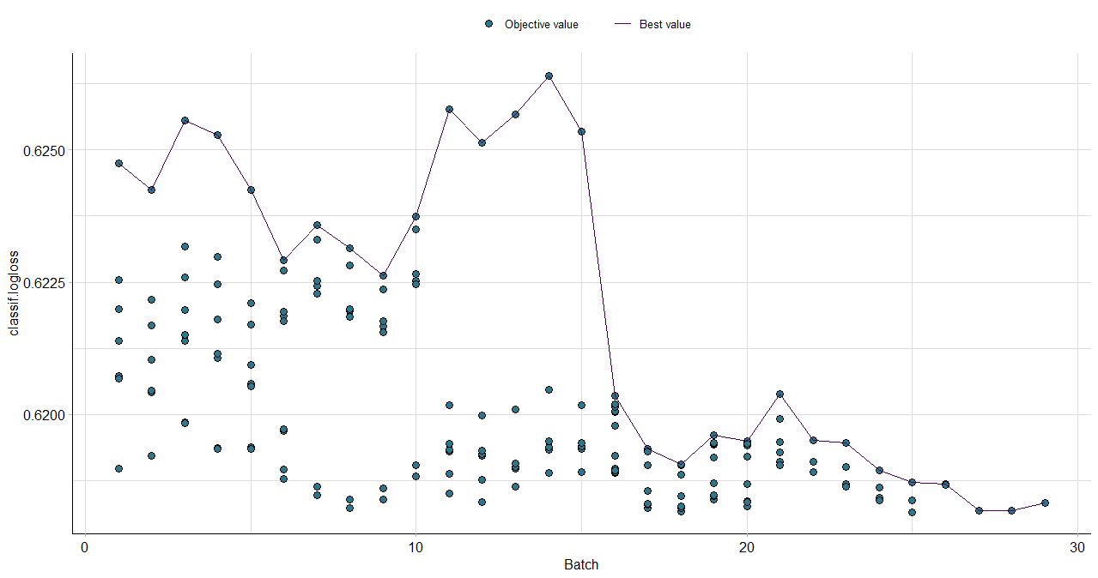
- We can see the evaluation metric (log loss) decreased along with more tuning
  - Here “batch” refers to the resampling (3 repeats with 10 folds)
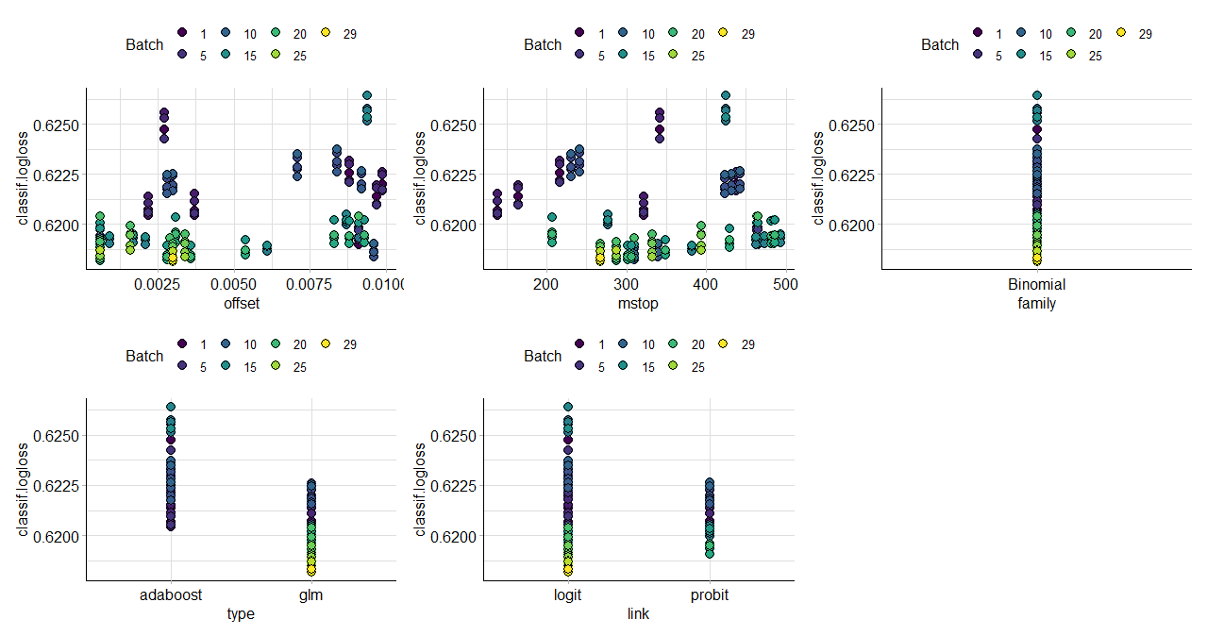
- We can see the different tuning parameters & their respective batch’s log loss value.
  - Logit, GLM, Binomial(only one) outperformed their counterparts
  - An mstop around 275 was ideal – stopping parameter, optimal number of boosting iterations
  - An offset around 0.0025 was ideal. This is used as a covariate that is added to the predictions.

Final Parts of Explanation:

- The tuning parameters were set on the model
- The model was then used to predict on the testing data.

- Evaluated the standard predictions
- Then incorporated classification thresholds

- Model visualization/interpretation tools were deployed

As mentioned on the code, there were multiple references for this project:
- https://cran.r-project.org/web/packages/mboost/index.html
- mlr3extralearners.mlr-org.com
- StackExchange
- GitHub
- “The irace package: Iterated racing for automatic algorithm configuration”
(López-Ibáñez, Dubois-Lacoste, et al. 2016)
- “A Racing Algorithm for Configuring Metaheuristics”
(Birattari, Stutzle, et al. 2002)
- (Buehlmann and Hothorn (2007))
- “About component-wise Boosting”

- Along with the rankings being equally likely, T has to be approximately X² distributed with n-1 degrees of freedom. Defining T & X, along with the equation required to evaluate the pairwise comparisons of the candidates would have dramatically increased the complexity & scope of this summary. Both equations are in the paper referenced. “A Racing Algorithm for Configuring Metaheuristics”

